***Florida International University***

*School of Computing and Information Sciences*

CIS 4911 - Senior Capstone Project

Software Engineering Focus

User Manual

Strategic Marketing Simulator 1.0

Team # 15

**Team Members**

Jeffrey Carman

Javier Andrial

**Product Owner**: Joseph Cilli

**Instructor**: Masoud Sadjari

Table of Contents

***Florida International University*** 1

Students 2

Creating an account 2

Logging into the system 4

Joining a group 5

Creating a new group 5

Strategic Decisions 6

Navigating the homepage 7

Score card 7

Leaderboard homepage view 7

Committing period decisions 7

Comments page 8

# 

# Students

## Creating an account

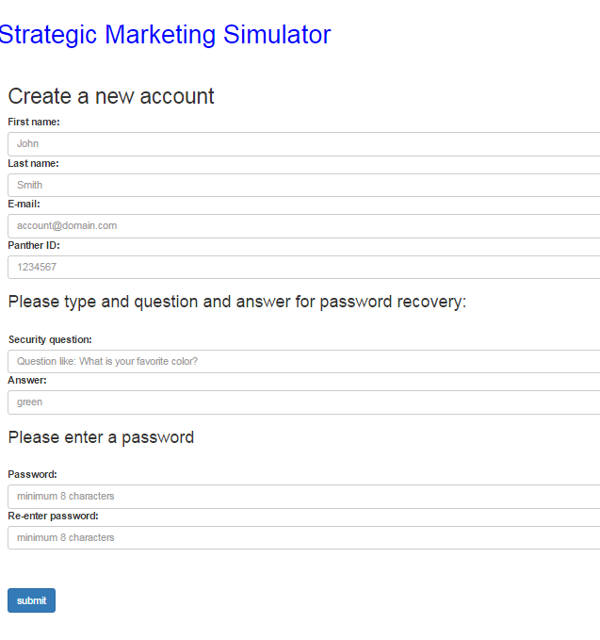

http://marketsim-dev.cis.fiu.edu/views/createAccount.php

Enter First Name, Last Name, E-mail address, Panther ID, Security Question Security Answer, and password. Next click submit. You will be redirected to the homepage.

## Logging into the system

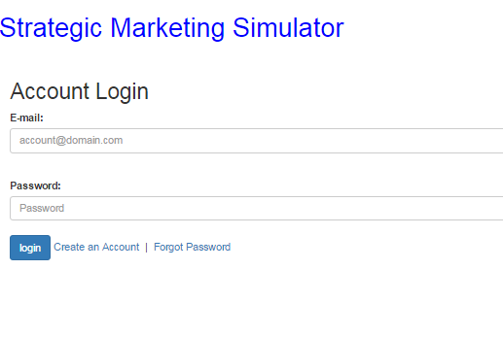

http://marketsim-dev.cis.fiu.edu/views/login.php

Enter username and password and click “login” button. You will be navigated to the homepage.

## Joining a group

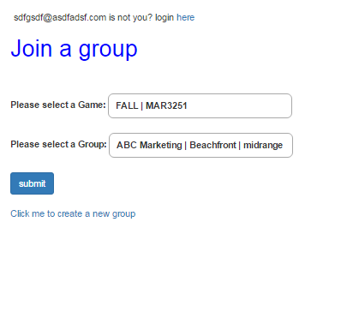

http://marketsim-dev.cis.fiu.edu/views/joinGroup.php

Select a game from the dropdown list. Next select a group from the dropdown list and click the submit button.

## Creating a new group

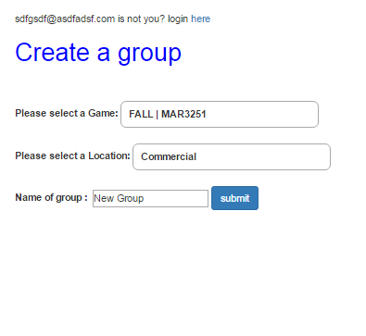

http://marketsim-dev.cis.fiu.edu/views/createGroup.php

Select a game from the dropdown list. Next select a location. Enter the name of your group in the name of group textbox and click the submit button.

## Strategic Decisions

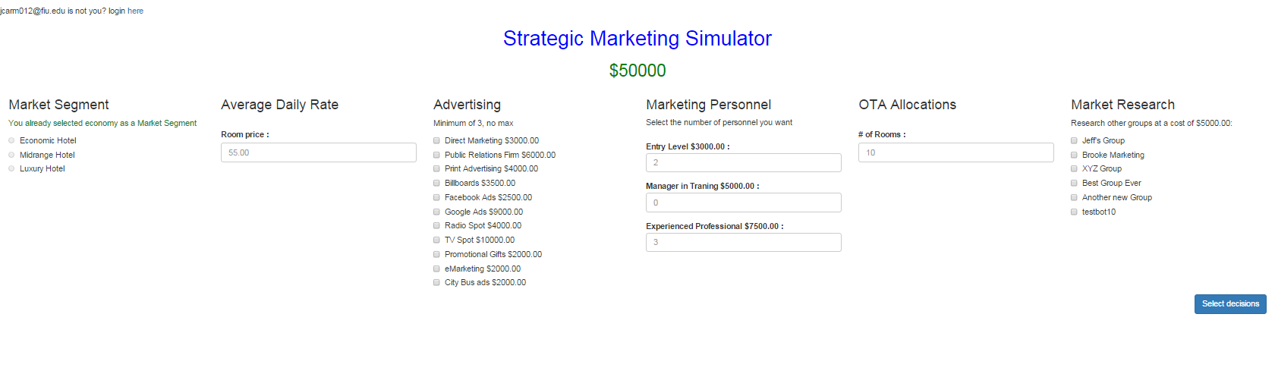

Navigate to: http://marketsim-dev.cis.fiu.edu/views/stratDecisions.php

Select one of the three market segment options. Next enter an average daily rate. Next select at least three of the advertising check boxes. You can also enter values for marketing personnel, OTA Allocations, and Market Research, but it is optional. One you have made your selection, click the “select decisions checkbox.

## Navigating the homepage

### Score card

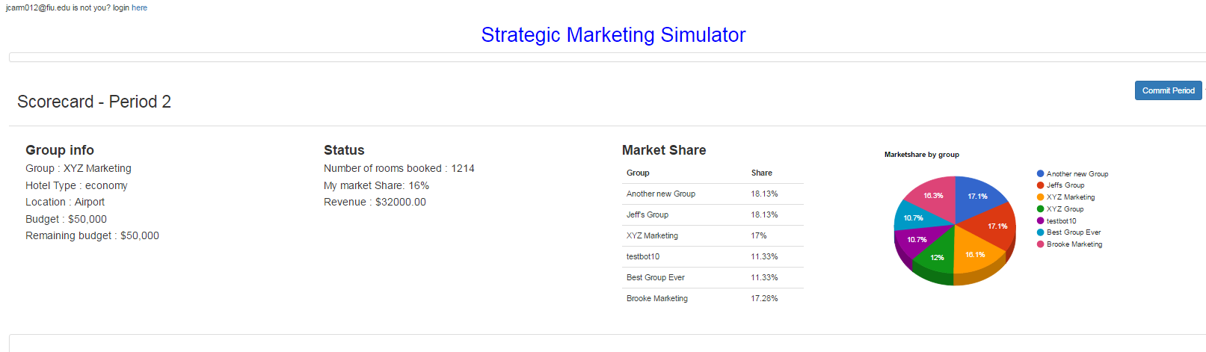

http://marketsim-dev.cis.fiu.edu/index.php

The scorecard shows your group information, market status, and market share.

### Leaderboard homepage view

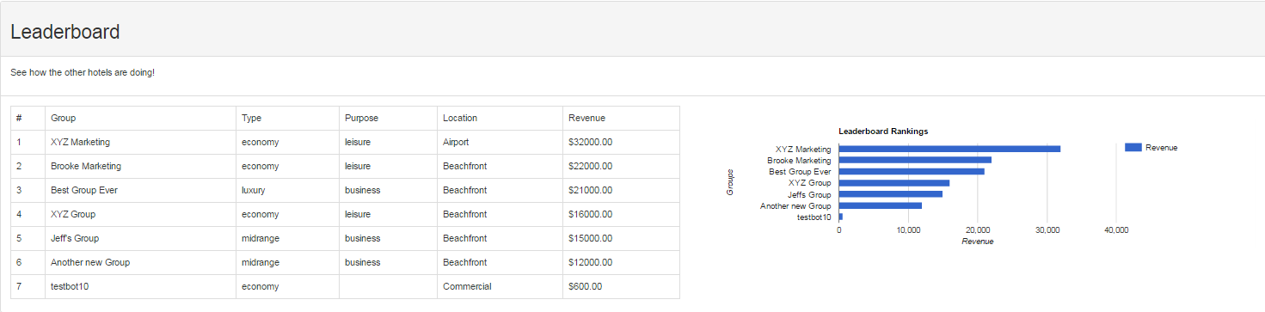

http://marketsim-dev.cis.fiu.edu/index.php

The leader board shows you the revenue for all groups in descending order

## Committing period decisions



From the homepage, click on commit period to be navigated to the comments page

### Comments page

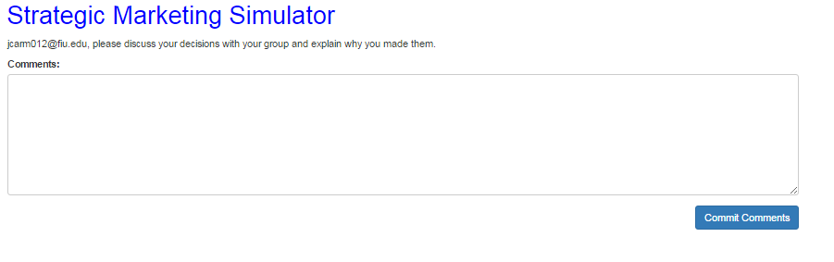

<http://marketsim-dev.cis.fiu.edu/views/commit.php>

Type the reasons for your decisions for this period and click commit comments.